Weiterentwicklung der Bildungsstandards in der Sekundarstufe I
für die erste Fremdsprache

Illustrierende Lernaufgabe für das Fach

Englisch

Kurzbeschreibung
Give a Helping Hand
Diese Aufgabe wurde von Fachexpertinnen und Fachexperten der Länder, überwiegend Lehrkräften, entwickelt. Die Aufgabenentwicklungsgruppe wurde von Wissenschaftlerinnen und Wissenschaftlern der Fachdidaktik Englisch beraten. Das Institut zur Qualitätsentwicklung im Bildungswesen hat den Prozess koordiniert.
Zusammenfassung:
Die Aufgabe besteht im Schreiben einer E-Mail an eine „Agony Aunt“. Die Schülerinnen und Schüler lernen, über persönliche Probleme zu sprechen und Ratschläge/Lösungsansätze für die Sorgen und Nöte anderer Menschen zu formulieren.
Funktionale kommunikative Kompetenzbereiche | Schreiben  Leseverstehen
Transversale  Kompetenzbereiche | Text- und Medienkompetenz
Lernergebnis / Produkt | E-Mail-Chat
Kommunikative Aktivitäten | dialogisches Sprechen anhand von Bildimpulsen, detailerfassendes Lesen, gestütztes Schreiben von E-Mails (Produktion)
Abschluss | Erster Schulabschluss (ESA)
Jahrgangsstufe | 8
Bearbeitungszeit | Gesamtbearbeitungszeit: 2 Unterrichtsstunden à 45 Minuten  Teilaufgabe 1: 15 Minuten  Teilaufgabe 2: 15–20 Minuten  Teilaufgabe 3: 5–10 Minuten  Teilaufgabe 4: 20 Minuten  Teilaufgabe 5: 20–25 Minuten
Hilfsmittel | Etherpad, digitales Wörterbuch

Illustrierte Standards
Schreiben: Schriftliche Interaktion (Teilaufgaben 4 und 5)
Die Schülerinnen und Schüler können
- aufgabenbezogen bzw. zweckgerichtet in sehr einfachen Texten zu vertrauten Themen schriftlich interagieren.
- in kurzen Korrespondenzen Informationen austauschen und dabei auf die Fragen einer anderen Person eingehen und antworten.
- sich an einfacher sozialer Kommunikation online beteiligen.
Leseverstehen (Teilaufgaben 2, 3 und 4)
Die Schülerinnen und Schüler können
- kurze, einfache Korrespondenz zu vertrauten Themen einschließlich der verwendeten Umgangsformen verstehen.
- beim Lesen auf ihnen vertraute (digitale) Werkzeuge zurückgreifen. Mitunter benötigen sie dabei Hinweise und Unterstützung.
Text- und Medienkompetenz (Teilaufgaben 2, 3, 4 und 5)
Die Schülerinnen und Schüler können
- einige, besonders häufig verwendete, (nicht-) sprachliche Gestaltungsmittel ihnen vertrauter Kommunikations- und Interaktionsformen erkennen und deuten. Mitunter benötigen sie dabei Hinweise und Unterstützung.

Aufgabe

Teilaufgabe 1: Describing pictures and talking to a partner.
The following images show youngsters in typical everyday situations which make them feel in different ways.
- Have a look at the pictures. Describe each situation in only one or two sentences.
- Who are these people?
- What is the situation like?
- What do you think – how do the persons feel?
- Why are they feeling that way? What could be problematic for the persons?
- Have you ever been in a similar situation? How did you feel or behave then?
- Talk to a partner and compare your ideas.
  Abbildung 1: KeithJJ (2016). | 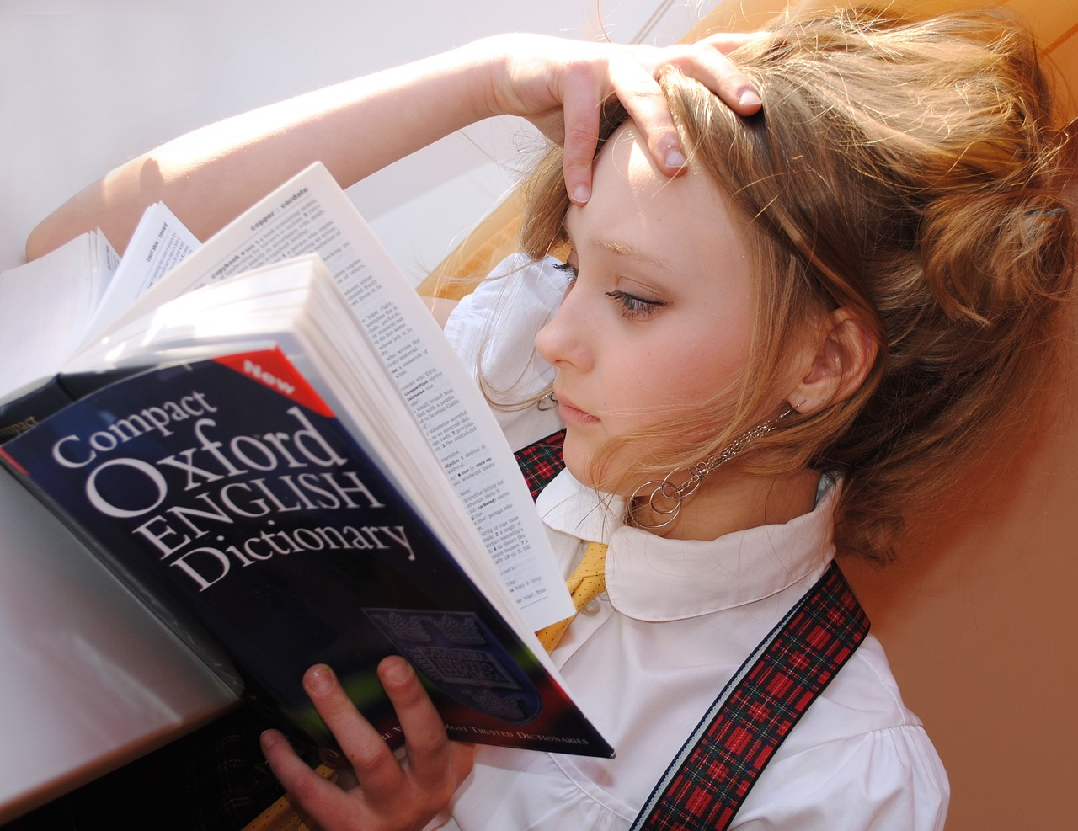  Abbildung 2: libellule789 (2017).
  Abbildung 3: JESHOOTS-com (2018). |   Abbildung 4: Alexandra_Koch (2022).
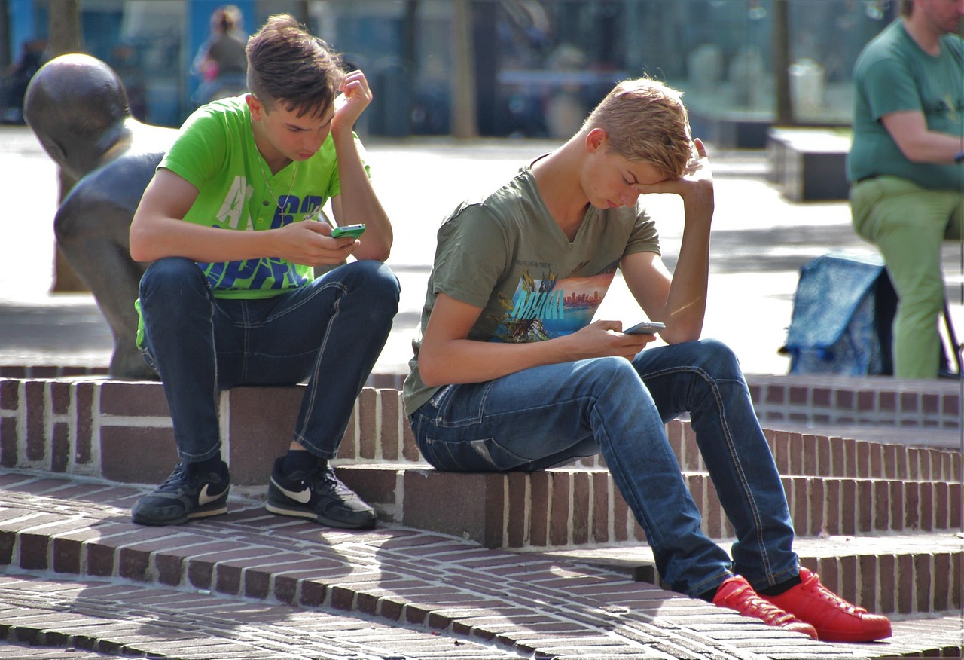  Abbildung 5: natureaddict (2016). |   Abbildung 6: Tumisu (2021).
Material 1a: Word bank – Describing pictures
Helpful phrases for describing pictures:
Criteria | Useful phrases
What is in the picture? | In the picture I can see ...  There’s / There are ...  There isn’t a ... / There aren’t any ...
Say what is happening  Using the present progressive | The man is ...  The children are…  The people are …  It’s raining.
Where in the picture? | at the top/bottom of the picture ...  in the middle of the picture ...  on the left/right of the picture ...  in the foreground/background  next to  in front of  behind  near  on top of  under
If something isn’t clear | It looks like a ...  It might be a ...  He could be ...  Maybe it’s a ...

In the following table you can find several words you can use to express emotions.
Before using the table find out the meaning of unknown words with a dictionary.
Material 1b: Word bank – Emotions
Joy | Security | Fear | Anger | Surprise | Sadness
Happy  Confident  Healthy  Strong  Optimistic  Inspired  Refreshed  Creative  Energized  Determined | Sure  Certain  Peaceful  Empowered  Confident  Ambitious  Calm  Respected  Content  Dynamic | Scared  Troubled  Anxious  Worried  Uncomfortable  Lost  Hurt  Insecure  Vulnerable  Uneasy | Agitated  Furious  Upset  Resentful  Mad  Disgusted  Frustrated  Annoyed  Outraged  Insulted | Confused  Alarmed  Startled  Astonished  Disappointed  Amazed  Distracted  Bewildered  Shocked  (in) Awe | Upset  Depressed  Empty  Crushed  Hurt  Sad  Miserable  Heavy  Abandoned  Sorrowful

Material 1c I: How you can talk about emotions – Examples to build up sentences
How you can talk about emotions – Examples to build up sentences
- refreshed – After a walk with my dog I feel refreshed.
- uncomfortable – I’m feeling uncomfortable about my new job.
- motivated – Finally I understood how to deal with the English tasks. I am very motivated right now.
- unsure – Whenever an unknown person speaks to Jason, he feels unsure.
Material 1c II: How you can talk about emotions – Phrases to build up sentences
How you can talk about emotions – Phrases to build up sentences

Why are you feeling (nervous)?
I am very (motivated) right now.
Whenever that happens, I feel really (insecure).

Teilaufgabe 2: Different problems.
The following e-mails from different teenagers illustrate different problems they are facing. To get some help, the teenagers described their problems to a person they trust (friends, relatives) in an e-mail.
Read the e-mails and find out which problems each teenager wrote about
Material 2: E-mails
From: audayou
To: vicchick
Date: 1st of 0ctober
Subject: This one photo

Hi Vicky,
I want to tell you about a problem I am having with a good friend of mine and hope you can give me some advice.

Last Friday night I sent a funny, but slightly embarrassing photo to Charlie. You know, I babysit our neighbor’s one-year-old son once a week. I held him in my arms after dinner and tried to take a selfie. At this very moment he vomited on my T-shirt. I sent the photo to Charlie because I found it funny and wanted her to have a laugh.

The next day, I found out that she had forwarded the picture to her friend Jason. How could she do that? It obviously was meant only for her.

Maybe I should not have sent it in the first place, but I didn’t expect her to send it to any other person. Especially not to Jason, who really likes to talk badly about people behind their back!

And what if he puts it on Facebook or Instagram or something? What if my parents see it? Or my neighbors (the babies’ parents)???

I feel so terrible.
What do you think I should do?
Please help me.

Yours,
Audrey

From: emma33
To: sammy66
Date: 8th of May
Subject: smombies

Dear Sammy,
I’m so annoyed with my boyfriend Simon.

Today we met for coffee and a chat. We sat there for half an hour, but we hardly talked to each other.

Simon was using his phone the whole time to text friends. He barely even looked at me!

I told him about my feelings – how disappointed and hurt I was. But I got the impression that he did not understand what I was talking about.
Maybe because he was not even listening to me!

I don’t think you should text while you are spending time with somebody. This is insulting to the person you are spending time with. Don’t you think?

This is not the way Simon thinks, quite the opposite. He doesn’t think it’s rude to use one’s phone on a date. He even thinks it’s rude to ignore messages!!

What do you think, Sammy? Is Simon right? Am I wrong? Or even old-fashioned?
Can you imagine how I felt after this date?

Maybe you can give me some advice on how to talk to my boyfriend. I even consider breaking up with him!

Waiting for your answer.

Yours,
Emily

From: daduke
To: philstar
Date: 5th of September
Subject: driving test

Hi Phil,

I really need your advice.

Last week I took my driver’s test and I didn’t pass it. I’ll probably have to retake it after additional lessons. My Mum still doesn’t know that I failed it.

How can I tell her that her beloved son was too tired to take the test? I am really ashamed to tell her because we went out with friends and I went to bed at two in the morning before my test. Usually I do not feel it but on that morning, I was so tired I was afraid I would fall asleep behind the wheel!

I feel so ashamed. My Mum paid all theory and drivers lessons. It was really expensive. And Mum makes so little money as a cashier in the supermarket.

I don’t want her to feel sad and disappointed.

What can I do? Do you think I could secretly take the test again and pay for the extra lessons myself or should I tell my Mum the truth?

Please help me.

Yours,
Duke

From: Nathan
To: Lisa
Date: 9th of November
Subject: stolen phone

Hi Lisa,

I’m in trouble. I really do need advice from my best cousin from Down Under.

This morning I borrowed my Dad’s phone without asking him. I had left mine at a friend’s place yesterday.

I used it in school to call some friends. I then met up with Judy and some others and we went to the cafeteria. When I got home, I realized I did not have the phone. I must have left it in the cafeteria. I immediately went back to ask for it, but they said that no phone had been found. What a nightmare!!!!!

Now I am feeling really bad because I stole my dad’s phone and then did not even take good enough care of it. What should I do?

Please give me advice, I feel so bad!

Your desperate cousin,
Nathan

Teilaufgabe 3: Different Problems. Check your knowledge.
After you have read all e-mails make sure you understand the different problems.
- Fill in the list.
- Describe each teenager’s problem in one to three short sentences.
Material 3
Sender | Problem the sender described in the e-mail
Audrey
Emily
Duke
Nathan

Teilaufgabe 4: An e-mail conversation.
What about you? Do you understand Audrey, Emily, Duke and/or Nathan? Have you been in a similar situation? What was it like? How did you feel then? Who would you write to if you were in the same situation?
- Think of a situation in your everyday life that causes problems regularly, perhaps in school, at home or in your free time.
- Write a short e-mail to your best friend who has moved to a different city. Describe the situation and explain how you feel about it. You could also write an e-mail to a newspaper “Agony Aunt”.
- Use the template for writing an e-mail.
- Check your e-mail for completeness using the checklist. If writing to your best friend, have a closer look at the informal e-mails. If you are writing to the student counselor or an Agony Aunt, your e-mail should be more formal. Maybe look up some examples on the internet. You can find lots of good models if you search for “examples of Agony Aunt letters”. Notice that chatbots also writes such letters quite easily. You could generate an example with a chatbot and use it as a model. But do not simply copy it without listing your source!
- Upload your text to our digital pinboard.
Discussion
- Choose one of your classmates’ e-mails or choose one from the reading task “Different problems”.
- Think of ways to help the person. Make sure to phrase your advice in a way that the person will not feel insulted (e.g. by using phrases like "you could" or "you might try to"). Use the material provided below to learn about the structure and different parts of this type of e-mail.
- If you want a challenge, take on the role of an “Agony Aunt” at a newspaper. This means that your advice needs to be especially well phrased!
- Answer the e-mail. Suggest concrete ways in which the person can deal with their problem(s).
- Use the template for writing e-mails.
- Check your e-mail text for completeness using the checklist.
- Upload your text to our digital pinboard.

Material 4: Template for e-mails
From: ………………………………………………………………………………………

To: ………………………………………………………………………………………

Date: ……………………………………………………………………………………….

Subject: ……………………………………………………………………………………….
Material 5: Checklist „How to write an e-mail“
Writing e-mails successfully
Beginning
I have written the subject/topic of my e-mail.
I have used
- a formal greeting (official e-mail to a person I do not know (well)) or
- an informal greeting (e-mail to a friend / family member).
Introduction
My first sentence begins with a capital letter.
At the beginning I have said why I am writing (purpose).
Main part
Everything I have said is important for the subject.
I have used paragraphs with topic sentences to structure my text (i.e. the first sentence of the paragraph explains what it is about)
Ending
I have finished with a
- formal good-bye (official e-mail / e-mail to a person I do not know) or
- friendly good-bye (e-mail to a friend).
I have signed the e-mail with my full name (formal) or first name (informal).
Final check
I have dealt with
- all the aspects relevant to the task
- the most important ideas from my notes.
My readers can understand my sentences.
I have used
- formal English for a person I do not know (very well)
- informal English for a friend / family member.
I have used a dictionary to check unfamiliar words/phrases.
I have used the grammar pages in my book to check sentence structures/grammar.
I have carefully checked the spelling of my text, or used an electronic spell checker.
I have asked a fellow student to give feedback on my text and improved my text using her/his tips.
Tabelle: In Anlehnung an: Nöth & Bauer, 2016, S.38
Material 6: Support – Writing an e-mail
Subject | Starting the E-Mail | Opening Sentence
- Seeking advice  - Problem regarding …  - Technical Difficulties  - Driving test  - Exam week | - Hi Nathan!  - Hello Audrey!  - Dear Mr /Mrs /Ms …,  - My dear sister / mother / friend, | - How are you?  - How is life treating you?  - What are you up to these days?  - Any news?
Giving News | Closing Sentence | Signature
- Guess what. I’ve …  - I’ve got some good / bad news.  - Great news, I’ve …  - I’m afraid I have some bad news. | - Well, that’s all for now.  - I’d better get back to…  - Looking forward to …  - Thank you for your help! | - Kind regards, …  - Best wishes, …  - Sincerely, …  - All the best / all my love, …  - With gratitude, …

Teilaufgabe 5: Writing the e-mail.
Now write the e-mail and send it to the person who stated the original problem. If you responded to a text from the reading task or wrote an Agony Aunt letter, give it to a classmate to read. Get their feedback and improve your mail. You can use the checklist in “Material 5” as a base for your feedback.
Agony Aunt letters need to be carefully phrased because the sender and the person giving advice do not know each other. Use the models below to write such letters. The individual stages (greeting, opening, etc.) are useful for this type of text in general.
Material 7: Example of an Agony Aunt letter
Dear Agony Aunt,
I hope this letter finds you well. I find myself in a rather sticky situation, and I desperately need your advice on how to handle it.
A few days ago, I was hanging out with my good friend, Susan, and her phone ended up in my sports bag by mistake. I didn't realize it at the time, and when I got home, I discovered her phone in my bag. I panicked and didn't know what to do. Instead of immediately returning it, I set it aside, thinking I would give it back the next time we met. However, a few days have passed, and I still haven't told her about it.
I'm feeling awful about this. Susan has been trying to contact me, and I've had to make excuses about not being available. I'm afraid of confessing that I accidentally took her phone, and now I'm afraid she'll be angry with me for not returning it earlier.
Can you tell me what to do?
Thank you for your advice and support.
Sincerely,
«The phone thief»
Text: ChatGPT, persönliche Kommunikation, 02. November 2023

You are writing from the position of the Agony Aunt? Use the following text as a model for a reply:
Dear "phone thief",
Thank you for getting in touch about your problem. It's clear that you care a lot about your friendship with Susan, and I'm glad you reached out for help on what to do. You've already taken the first step, which is a good thing. I'm here to guide you through this.
Mistakes can be tough to admit, but it's necessary to keep a good and honest friendship. Here's how you can handle this:
1. Choose a Good Time and Place: Find a quiet, private moment to talk to Susan. You want her to be able to focus on what you're saying without any distractions.
2. Be Honest: When you talk to her, just tell her what happened. Explain that you didn't mean to keep her phone and you're sorry you didn't give it back sooner.
3. Say Sorry: Apologize sincerely for any trouble this has caused her and any frustration she felt because you had her phone.
4. Offer to Help: To show you're serious about making things right, offer to assist her in any way you can. You could help with any important calls or messages she missed, or cover any costs if her phone needs fixing or replacing.
5. Learn from Your Mistake: Think about what happened and figure out how to avoid it in the future.
True friendships are built on trust and understanding. By handling this honestly and responsibly, you can make your friendship with Susan even stronger.
I hope this helps you with your situation.
Sincerely,
Your Agony Aunt
Text: ChatGPT, persönliche Kommunikation, 02. November 2023
Material 8: Support: Useful phrases in an Agony Aunt letter
How to reply to an Agony Aunt letter/e-mail

Follow this plan:
- Express your sympathy and try to calm the person down.
- Analyze the problem.
- Recommend /suggest how the problem could be solved.

Use expressions:
- I’m sorry to hear that…
- I can understand that …
- It/The situation must be very hard/difficult/… for you.
- I think …
- You should …
- You could …
- Why don’t you …
- If I were you ….
- Why not …
- Maybe …
- I (really) suggest …
- You should talk to …/…
- It’s always a good idea to talk things over with …
- One way to deal with this problem might be to …
- My advice is to …
- The (most important piece of) advice I want to give you is …
- Perhaps you should think about …
- It might be a good idea to …

Didaktischer Kommentar

Relevanz der Aufgabe
Jugendliche holen sich Ratschläge heute in der Regel im Internet ein, zum Beispiel in Kommentarspalten in sozialen Netzwerken. Hier interagieren sie häufig mit englischsprachigen Accounts. Der Austausch über eigene Gefühle und Dilemmata passiert in ihrer Lebenswelt dadurch häufig in englischer Sprache. In der vorliegenden Aufgabe üben sie diese schriftliche Interaktion gezielt mit dem Einsatz von passenden Formulierungen, der Einhaltung einer Struktur ihrer Texte sowie dem Prüfen der sprachlichen Angemessenheit.

Ziel der Aufgabe
Bei der Bearbeitung der Aufgabe „Give a Helping Hand“ sollen die Lernenden unter anderem in die Lage versetzt werden, sich in eine andere Person emotional hineinzuversetzen. Außerdem sollen Probleme aus den eigenen Alltagserfahrungen der Jugendlichen in einer schriftlichen Konversation benannt und beschrieben sowie deren mögliche Lösungen erörtert werden. Gegebenenfalls sollen Ratschläge unter Beachtung der speziellen Textsorte „personal e-mail” gegeben werden. Hierbei ist der kommunikative Rahmen zu berücksichtigen, z. B. kann einem besten Freund geschrieben werden, der in eine andere Stadt gezogen ist, oder aber auch der sogenannten „Agony Aunt“.

Erforderliche Vorkenntnisse
Für die Bearbeitung der Aufgabe sollen die Schülerinnen und Schüler in der Lage sein, aus einem Repertoire von Lesetechniken und Strategien zur Bedeutungserschließung selbstständig die passenden auszuwählen und anzuwenden, um authentischen Texten zu vertrauten Alltagsthemen und Themen, die mit eigenen Interessen in Zusammenhang stehen, gezielt Hauptaussagen (global) und Einzelinformationen (selektiv) entnehmen zu können.

Hinweise zur Durchführung und Differenzierungsmöglichkeiten
Neben den in der Aufgabenstellung ausgewiesenen Materialien (Template for e-mails, Checklist „How to write an e-mail“) eignen sich zur Unterstützung leistungsschwächerer Schülerinnen und Schüler die Wortlisten zur Beschreibung von Bildern bzw. Gefühlen in Teilaufgabe 1, die für das Kompetenzniveau A2 auch noch vereinfacht werden sollten sowie die Materialien in Teilaufgabe 4.
Schülerinnen und Schülern, die leistungsstärker sind oder denen es unangenehm ist, sich auf die emotionale Herausforderung der Aufgabe einzulassen, haben die Möglichkeit, die Rolle einer offiziellen „Agony Aunt“ zu übernehmen. Hierbei besteht die Differenzierung in der Tatsache, dass die Kommunikation in einem öffentlichen Forum online stattfinden soll. Für diesen Kontext sind die Textmodelle in „Material 7“ hilfreich. Weiterhin ist es ratsam, die Schülerinnen und Schüler zu einem gegenseitigen Feedback bezüglich ihrer selbst geschriebenen Texte aufzufordern. Als Arbeitsmittel eignet sich hier die Checklist „How to write an e-mail“ (Material 5).
Nachdem sie das Feedback erhalten haben, können die Schülerinnen und Schüler ihre Texte noch einmal überarbeiten und dann in bereinigter Form publizieren (z. B. Upload ins Klassenforum).

Lösungen
Teilaufgabe 1: Describing pictures and talking to a partner
Abbildung 1: KeithJJ (2016).  This picture shows a team hugging each other. Maybe they are relieved and happy about a victory. | Abbildung 2: libellule789 (2017).  The picture shows a student learning English. She seems very focused and concentrated.
Abbildung 3: JESHOOTS-com (2018).  The picture shows a woman sitting in front of her laptop biting a pen. Maybe she's getting a little frustrated. | Abbildung 4: Alexandra_Koch (2022).  In the picture, the boy holds his hands in front of his face. He might be tired and exhausted.
Abbildung 5: natureaddict (2016).  These two friends in the picture sit next to each other and look at their phones. Maybe they are a kind of bored. | Abbildung 6: Tumisu (2021).  This picture shows a girl in the foreground looking worried. Maybe the girls in the background are talking about her.

Teilaufgabe 3: Different Problems. Check your knowledge.
Sender | Problem the sender described in the e-mail
Audrey | A friend abused her trust and sent a very personal photo to someone else who might upload it on social media.
Emily | She is annoyed by her boyfriend after he was on his phone the whole time they were on a date.
Duke | He didn’t pass the driver’s test because he went out the night before.  oder  He didn’t pass his driver’s test because he didn’t follow his mum’s advice.
Nathan | He stole his dad’s phone, lost it, and is now afraid of his dad’s reaction.

Teilaufgaben 2,4 und 5:
Die Schülerinnen und Schüler entwickeln individuelle Lösungen.

Quellenangaben
- Abbildung 1: Copyright Grafik: KeithJJ. (2016, 4. August). Volleyball Team Feier Sieg. Pixabay. https://pixabay.com/de/photos/volleyball-team-feier-sieg-gewinner-1567762/
- Abbildung 2: Copyright Grafik: libellule789. (2017, 21. September). Mädchen Englisch Wörterbuch. Pixabay. https://pixabay.com/de/photos/m%C3%A4dchen-englisch-w%C3%B6rterbuch-lesen-2771936/
- Abbildung 3: Copyright Grafik: JESHOOTS-com. (2018, 18. Januar). Laptop Frau Bildung. Pixabay. https://pixabay.com/de/photos/laptop-frau-bildung-lernen-jung-3087585/
- Abbildung 4: Copyright Grafik: Alexandra_Koch. (2022, 29. Januar). Schüler Mann Verzweifelt. Pixabay. https://pixabay.com/de/photos/sch%C3%BCler-mann-verzweifelt-depression-6976999/
- Abbildung 5: Copyright Grafik: natureaddict. (2016, 29. Juli). Pokémon Pokemon gehen Telefon. Pixabay. https://pixabay.com/de/photos/pok%C3%A9mon-pokemon-gehen-telefon-spiel-1553971/
- Abbildung 6: Copyright Grafik: Tumisu. (2021, 6. Februar). Frau Tyrannisieren Verspottung. Pixabay. https://pixabay.com/de/photos/frau-tyrannisieren-verspottung-5985784/
- Material 5: In Anlehnung an: Nöth, D. & Bauer, F. (2016) Textsortenspezifisches Schreiben im Englischunterricht der Sekundarstufe I. Materialien zum selbstständigen Lernen. Senatsverwaltung für Bildung, Jugend und Wissenschaft, S. 38. https://bildungsserver.berlin-brandenburg.de/fileadmin/bbb/unterricht/unterrichtsentwicklung/Individualisierung_des_Lernens/HANDREICHUNG_ONLINE-FINAL_06.05.16.pdf
- Material 7: ChatGPT, persönliche Kommunikation, 02. November 2023

Sofern nicht anders gekennzeichnet, liegt das Copyright beim IQB e.V., Lizenz: Creative Commons (CC BY). Volltext unter: https://creativecommons.org/licenses/by/4.0/legalcode.de

Agony Aunt letters are anonymous letters that are written to a newspaper or blog asking for advice on a certain topic or situation. These are usually personal problems which the writer is seeking advice for, so you have to be more careful in your language use. Your style should be more formal and you should describe the problem in enough details so that readers can understand you. Choose this “Agony Aunt” format only if you want a special challenge!

